Kenwood TS-890

**Aki Yoshida JA1NLX and Filipe Lopes CT1ILT**

**1.0 GENERAL**

This section will provide basic TS-890 setup and useful information.

## 2.0 SETUP

**2.1 Setup Radio Dialog Box**

This is a Setup Radio dialog box for the TS-890. Select Kenwood TS-990 as Radio.

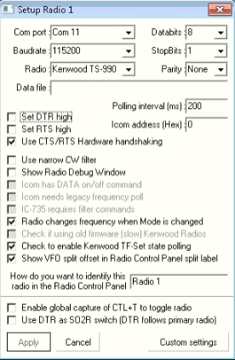

TS890_1

**2.2 How to share comport**

For some reason user want to share radio com port with Logger32 and JTDX. In this case user should run JTDX directly (not from Start menu in UDP BandMap)

Example: While running FT8 using JTDX you may want to QSY to any frequency/mode which is spotted.

This is an example to share com port using VSPE. VSPE should be configured below.

Note: Sharing com port using VSPE may not always work properly depending on radio type. Elecraft K3 is a sample with which VSPE does not work.

* Configure the COM port as SPLITTER

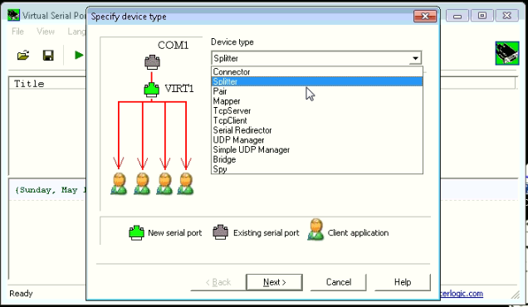

TS890_2

* Set the source COM port, which you can confirm in DEVICE MANAGER and set a Virtual COM port, this port will be used on your softwares.

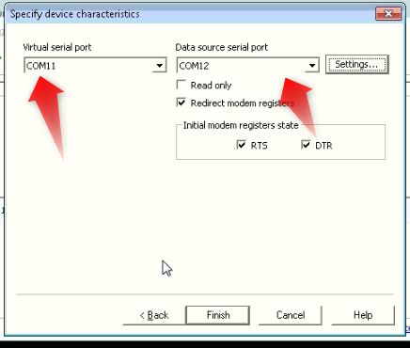

TS890_3

* Do not forget to go under Settings to set your Baudrate.

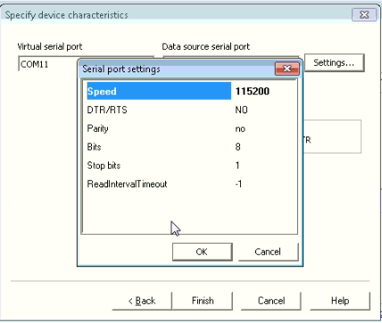

TS890_4

* Last step is to start the virtual COM port you configured.